IMPORTANT ROAD CLOSURE INFORMATION - SUNDAY 25th MARCH 2018

The London Landmarks Half Marathon is a closed road 13.1 mile running event that is taking place in the area on Sunday 25th March. It is a charity owned event enabling thousands of runners to raise vital funds for 102 official charities.
The list of the key affected roads and their closure times is below, these are the planned times but they may be subject to change.
Emergency Services and pedestrian access will be facilitated throughout, but there will be no vehicle or bicycle access on these roads during the closure period. Visit www.tfl.gov.uk to see if your public transport journey by bus is affected.

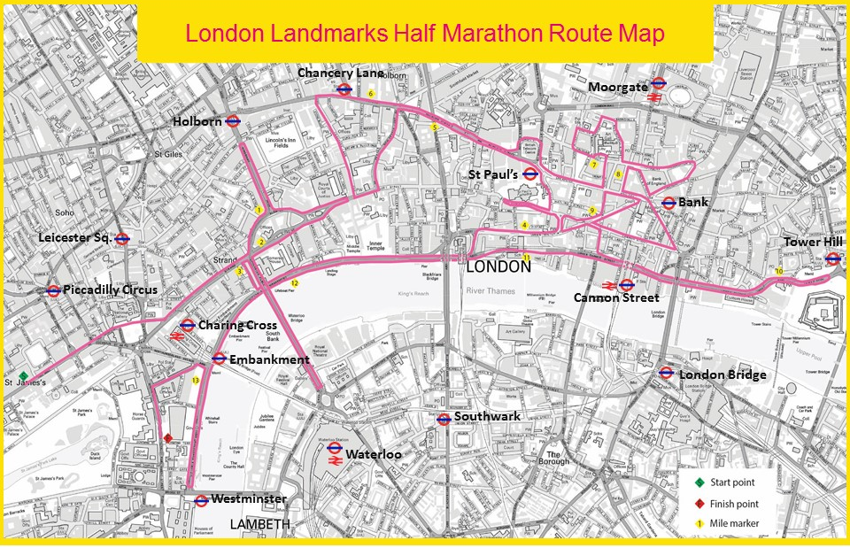

ROAD NAME (Alphabetical Order) | Closure Time |  | ROAD NAME (continued) | Closure Time
Aldermanbury | 07:00 – 14:15 |  | Northumberland Avenue | 05:00 – 15:15
Aldwych | 07:00 – 12:30 |  | Old Broad Street | 07:00 – 14:15
Angel Street | 07:00 – 13:15 |  | Pall Mall (St James St to Waterloo Place) | 05:00 – 13:45
Bartholomew Street | 07:00 – 14:15 |  | Pall Mall (Waterloo Place to Haymarket) | 05:00 – 12:30
Blackfriars Underpass | 08:00 – 15.15 |  | Pall Mall East | 02:30 – 17:00
Cannon Street (between Queen Victoria Street & St Paul's Churchyard) | 07:00 – 14:15 |  | Poultry | 07:00 – 14:15
Chancery Lane | 07:00 – 13:15 |  | Princes Street | 07:00 – 14:15
Cheapside | 07:00 – 14:15 |  | Puddle Dock | 07:00 – 14:15
Cockspur Street | 05:00 – 13:45 |  | Queen Street | 07:00 – 14:15
Duncannon Street | 05:00 – 12:30 |  | Queen Victoria Street | 07:00 – 14:15
Fleet Street | 07:00 – 13:15 |  | Savoy Street | 05:00 – 15:15
Friday Street | 07:00 – 14:15 |  | St Martins-Le-Grand | 07:00 – 13:15
Gresham Street | 07:00 – 14:15 |  | St Paul's Churchyard | 07:00 – 14:15
Holborn | 07:00 – 13:15 |  | Strand | 05:00 – 12:30
High Holborn | 07:00 – 13:15 |  | Strand Underpass (Northbound) | 08:50 – 11:30
Holborn Viaduct | 07:00 – 13:15 |  | Threadneedle Street | 07:00 – 14:15
King Edwards Street | 07:00 – 13:15 |  | Throgmorton Street | 07:00 – 14:15
King William Street | 07:00 – 14:15 |  | Upper Thames Street | 08:00 – 15:15
Kingsway | 07:00 – 12:30 |  | Victoria Embankment | 08:00 – 15:15
Lothbury | 07:00 – 14:15 |  | Waterloo Bridge | 07:00 – 12:30
Love Lane | 07:00 - 14:15 |  | Whitehall | 05:00 – 18:00
Lower Thames Street | 08:30 – 14:30 |  | Whitehall Place | 05:00 – 18:00
New Change | 07:00 – 14:15 |  | Wood Street (between Love Lane & Gresham Street) | 07:00 – 14:15
New Fetter / Fetter Lane | 07:00 – 13:15

:::

Please note that side streets with access onto the roads listed above may also be affected

The table overleaf lists most of the other side roads where access/egress will also be affected
Side roads where access / egress will also be affected
Please ensure your building’s emergency evacuation plan is amended during the above times if they are affected by the closures
For further information about the event please visit www.llhm.co.uk

For access assistance / queries before or after Sunday 25th March, please contact roadclosures@humanrace.co.uk or 020 8391 3913

For urgent assistance on Event Day please call 07541 575 783
(line will be open 04.30 – 18.00 on Sunday 25 March Only)
ROAD NAME (Alphabetical Order) | Closure Time |  | ROAD NAME (continued) | Closure Time
Adam Street | 08:00 – 12.30 |  | Little Essex Street | 07:00 – 12:30
Adelphi Terrace | 08:00 – 12:30 |  | Little James Street | 05:00 – 13:45
Allhallows Lane | 08:30 – 14:30 |  | Little Trinity Lane | 07:00 – 14:15
Angel Lane | 08:30 – 14:30 |  | Lower Robert Street | 08:00 – 12:30
Arthur Street | 08:30 – 14:30 |  | Marlborough Road | 05:00 – 13:45
Arundel Street | 07:00 – 12:30 |  | Martin Lane | 07:00 – 14:15
Bartholomew Lane | 07:00 – 14:15 |  | Middle Temple Lane | 08:00 - 15:15
Bell Wharf Lane | 08:30 – 14:30 |  | Milford Lane | 07:00 – 12:30
Bread Street | 07:00 – 14:15 |  | Milk Street | 07:00 – 14:15
Breams Building | 07:00 – 13:15 |  | Northumberland Street | 05:00 – 15:15
Broken Wharf | 08:00 – 15:15 |  | Norwich Street | 07:00 – 13:15
Buckingham Street | 08:00 – 12:30 |  | Old Bailey | 07:00 – 14:15
Bucklersbury | 07:00 – 14:15 |  | Oxford Court | 07:00 – 14:15
Bush Lane | 07:00 – 14:15 |  | Pancras Lane | 07:00 – 14:15
Carlton Gardens | 05:00 – 13:45 |  | Petty Wales | 08:30 – 14:30
Carlton House Terrace | 05:00 – 13:45 |  | Playhouse Yard | 07:00 – 14:15
Carting Lane | 08:00 – 12:30 |  | Queen Street Place | 08:30 – 14:30
Castle Baynard Street | 08:00 – 15:15 |  | Richmond Terrace | 05:00 – 18:00
Cleveland Row | 05:00 – 13:45 |  | Russia Row | 07:00 – 14:15
Cloak Lane | 07:00 – 14:15 |  | Salters Hall Court | 07:00 – 14:15
Cockspur Court | 05:00 – 12:30 |  | Savoy Hill | 08:00 – 12.30
College Hill | 07:00 – 14:15 |  | Savoy Place | 08:00 – 12.30
Cousin Lane | 08:30 – 14:30 |  | Savoy Row | 08:00 – 12.30
Craigs Court | 05:00 – 18:00 |  | Savoy Way | 08:00 – 12.30
Craven Street | 05:00 – 15:15 |  | Scotland Place | 05:00 – 18:00
Cursitor Street | 07:00 – 13:15 |  | Sherborne Lane | 07:00 – 14:15
Derby Gate | 05:00 – 18:00 |  | Skinners Lane | 07:00 – 14:15
Distaff Lane | 07:00 – 14:15 |  | Southampton Buildings | 07:00 – 13:15
Dowgate Hill | 07:00 – 14:15 |  | Spring Gardens | 05:00 – 12:30
Durham House Street | 08:00 – 12.30 |  | St James Square | 05:00 – 13:45
Embankment Place | 05:00 – 15:15 |  | St Swithins Lane | 07:00 – 14:15
Essex Street | 07:00 – 12.30 |  | Stew Lane | 08:00 – 15:15
Fetter Lane | 07:00 – 13:15 |  | Suffolk Lane | 07:00 – 14:15
Fish Street Hill | 08:30 – 14:30 |  | Suffolk Street | 05:00 – 12:30
Fredericks Place | 07:00 – 14:15 |  | Surrey Street | 07:00 – 12:30
Furnival Street | 07:00 – 13:15 |  | Swan Lane | 08:30 – 14:30
Garlick Hill | 07:00 – 14:15 |  | Temple Place | 07:00 – 12:30
George Court | 08:00 – 12.30 |  | The Mall | 05:00 – 18:00
Gophir Lane | 07:00 – 14:15 |  | Threadneedle Walk | 07:00 – 14:15
Great Scotland Yard | 05:00 – 18:00 |  | Trig Lane | 08:00 – 15:15
Great St Thomas Apostle | 07:00 – 14:15 |  | Trump Street | 07:00 – 14:15
Great Tower Street (between Mark Lane & Tower Hill) | 08:30 – 14:30 |  | Villiers Street | 08:00 – 12:30
Great Trinity Lane | 07:00 – 14:15 |  | Warwick House Street | 05:00 – 12:30
Haymarket | 05:00 – 12:30 |  | Water Lane | 08:30 – 14:30
High Timber Street | 08:00 – 15.15 |  | Water Street | 07:00 – 12:30
Horse Guards Avenue | 05:00 – 18:00 |  | Waterloo Place | Sat + Sun
Horse Guards Road | 05:00 – 18:00 |  | Waterloo Place North / Regents street | 05:00 – 12:30
Ironmonger Lane | 07:00 – 14:15 |  | Watling Street | 07:00 – 14:15
John Adam Street | 08:00 – 12.30 |  | Well Court | 07:00 – 14:15
Kennett Wharf Lane | 08:00 – 15.15 |  | Whitcomb Street | 05:00 – 12:30
King Charles Street | 05:00 – 18:00 |  | Whitehall Court | 05:00 – 18:00
Lambeth Hill | 08:00 – 15.15 |  | Wood Street (between Love Lane & London wall) | 07:00 – 14:15
Laurence Poutney Hill | 07:00 – 14:15 |  | York Buildings | 08:00 – 12:30
Laurence Poutney Lane | 07:00 – 14:15 |  | York Place | 08:00 – 12:30
Lawrence Lane | 07:00 – 14:15

